Hello Everyone,
Well it’s nearly that time again when all of our school leavers are heading off to school. We would like to wish them all lots of luck and we will miss you all, we would love for you come and visit us.

Regards
Emma

Nursery Holidays:

Bank Holiday – Monday 26th August

Christmas Nursery Holidays break up on Tuesday 24th December at 4pm

Return to Nursery on Thursday 2nd January 2014

Term Time Holidays: For government funded sessions & term time children only

Summer Holidays break up Friday 19th July
Return to Nursery Monday 2nd September

Monday 28th October – Friday 1st November


Honeybuns now has a Facebook page! Parents are welcome to visit our ‘Honeybuns Nurseries’ page and share it with their Facebook friends. We will update the page with information of up and coming events along with relevant information.
Honeybuns is also on Twitter, follow us @HoneybunsDN.

Staff:

Butterflies – Emma, Beth, Amy D
Squirrels – Natalie, Stacey, Alice
Foxes – Rachael, Sarah, Mary
Hedgehogs – Becky, John
If you have any questions please do not hesitate to come and speak to us.
New Staff

We would like to welcome Alice Hardware to our team she will be working in all areas of nursery.
We would also like to welcome Claire Davies who will be helping us out covering holidays until the end of August.

Reminders

- Please keep us informed of any changes to contact details, particularly mobile phone numbers; it is essential that we are able to contact parents at all times.
- Please provide your child with some sun cream or a sun hat if they are not having nursery sun cream.

Upcoming Events

Family Trip to the Beach
Saturday 27th July 2013
Our trip to Southport is all booked thank you to everyone that has paid could I ask anyone that hasn’t to get their money in as soon as possible.
The coach will be leaving nursery at 8.15am if you could get here for 8am. We will be returning back at 4pm. There will be a chance to meet up on the day this will be arranged on the bus.

Decorating:
Over the next few months we are starting to decorate the rooms and the hallway there will be no disruption to the rooms as they will be decorated over a weekend. The hallway paper is being removed and that will be done towards the end of a week.

Beach Party:
Wednesday 21st August
We will be having a beach party on this day if your children can bring their beach wear and a towel in a bag with their name on.
We will have a little picnic also for tea lots of fun activities will be available all day.
Room Activities & Events

Butterflies:
Our theme for July is Holidays and summer we will be having a week of fun where each child will enjoy a beach party. A letter will follow shortly with all the details on.

Squirrels:
Our theme for July is Holidays and summer we will be asking for you to bring some photo’s in of the children on their holidays so we can talk about them in a group.

Foxes:
Our theme for July is Summer and Transport we will be asking for you to bring some photo’s in of the children on their holidays so we can talk about them in, we also be having a beach party the date for this is opposite. We will be also going on a trip on the bus to talk about different ways to travel.

Hedgehogs Graduation:
Thank you to all the children and parents who attended our graduation party on Saturday 29th June. Everyone had a good time and lots of fun !
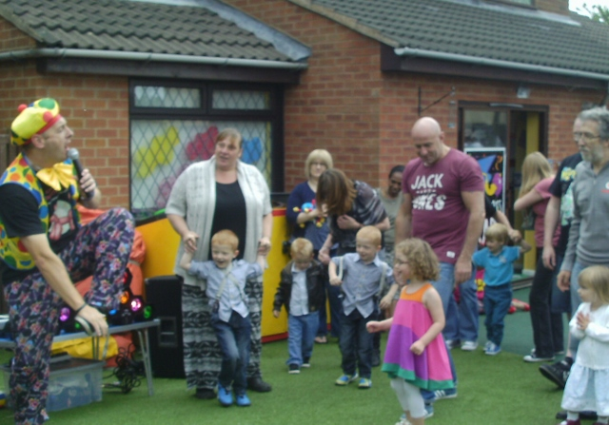

A Big Thank you
Thank you to everyone that came to our summer fair the weather was a little unkind to us this year we had a lovely day though.
We have raised £400.00
Our chosen charity is: Great Ormand Street

Donations:
We are also looking for some drain pipes, tubing, and logs for our garden area if any of the parents can help us as we are trying to develop our garden area.

We are also asking for any spare clothes for all ages also pants, and socks if anyone can donate them to us please.

School Leavers:
If your child is leaving for school this year could you let us know which school they will be going to so we can forward on their transition sheets. Also just to remind parents you have to give a month’s notice please.
Leaps and Bounds
The leaps and bounds will finish on the 18th July and restart in September as long as we have enough children to take part a letter will be coming out in July to see if there is any interest in taking part.

