Christmas Holiday 2013 Booking Form

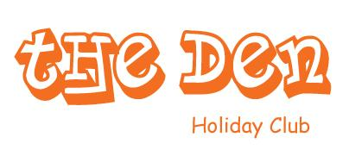

**Childs Name: Parent Signature:**

**Date**:

**Costs:**

**Costs**

* Per Day £21.00
* Half Day £13.30

|  |  |  |  |
| --- | --- | --- | --- |
|  | Full Day | 8.00am -1pm | 1pm – 6pm |
| **Mon 23rd Dec** |  |  |  |
| **Tues 24th Dec**  **CLOSE at 4pm** |  |  |  |
| **Thurs 2nd Jan** |  |  |  |
| **Fri 3rd Jan** |  |  |  |



Please Note: Fees are due at the time of booking at least one week in advance of the child attending ‘The Den’. Additional charges may apply to some activities. Days are non-transferrable.